**Create A Dashboard On Items Report**

Create a dashboard on Items report:

1. Click on new Dashboard.

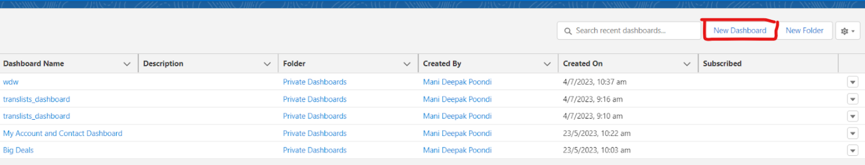

1. Enter the name of the dashboard.

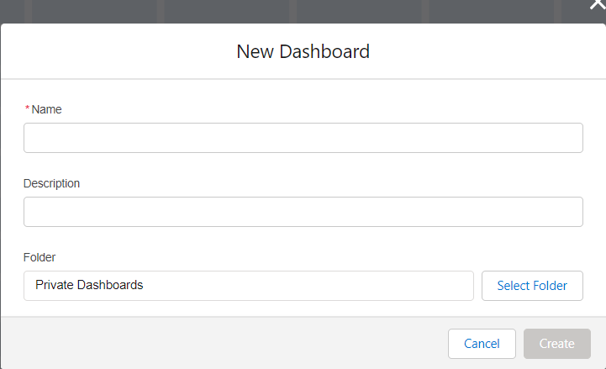

 3)Upon clicking create, you will notice an empty dashboard. Click on New component.

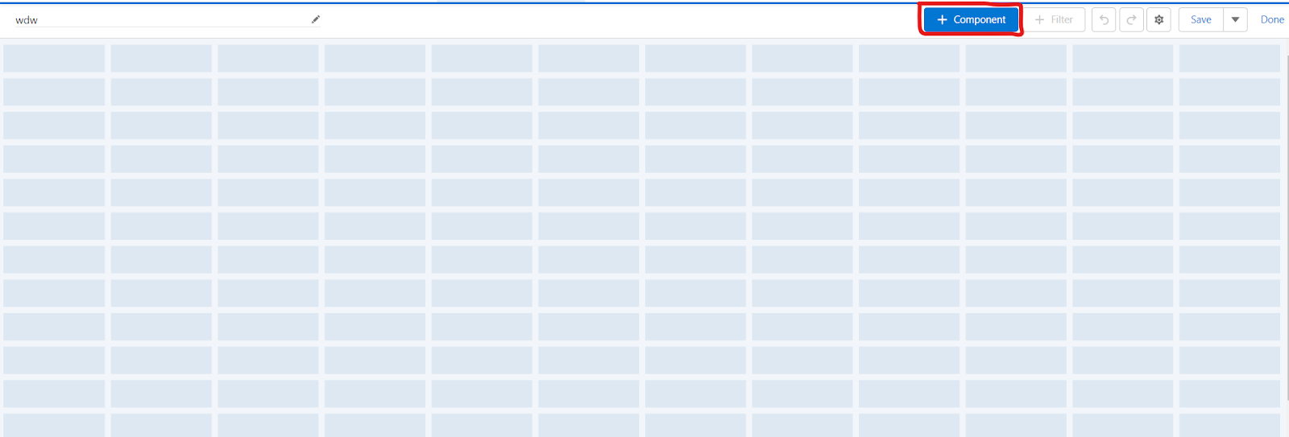

4) Click on “**+** Component”, and click on translists report.

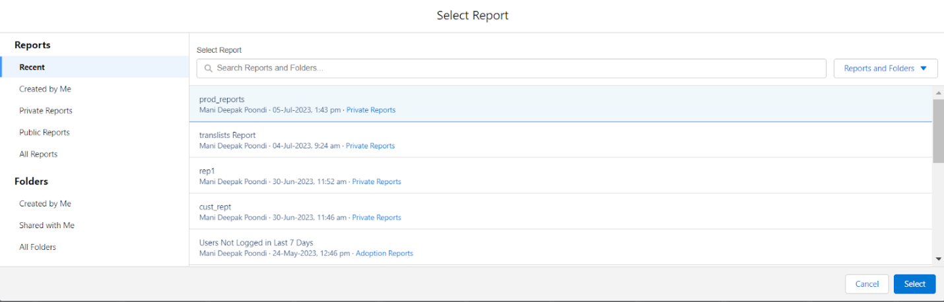

5) Click on select and in the add component section, select all the fields required for the dashboard. Click on add component and add display as pie chart view.(if possible select dark mode for better experience).

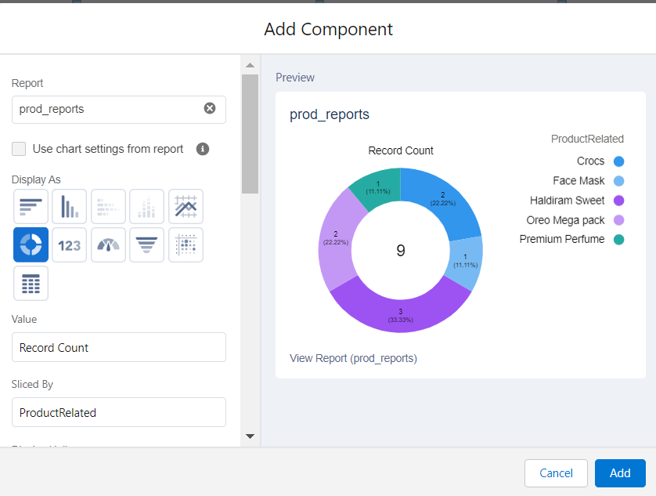

6) Click on add. You can now see the pie chart dashboard of how many of those items are most sold and count of the items.

